Lecture 1

Focus on there topics :-

- What is Automation ?
- What is Shell Scripting ?
- Why only bash for Shell Scripting ?
- Example task for Automation
- How to implement Automation with bash shell scripting ?
- Why Automation ?
- Different Scripting Languages for Automation
- Who can take this course ?

Automation - completing task with scripting.

Shell - is a program/interpreter that provides an interface between user and an OS (kernel).

When you login in system , by default kernel will assign one terminal to each user.
Mostly available shells are - BASH shell , SH shell , ksh shell , csh …….

$ which $SHELL -> to know what shell we are using

$ cat /etc/shells -> to print list of shell

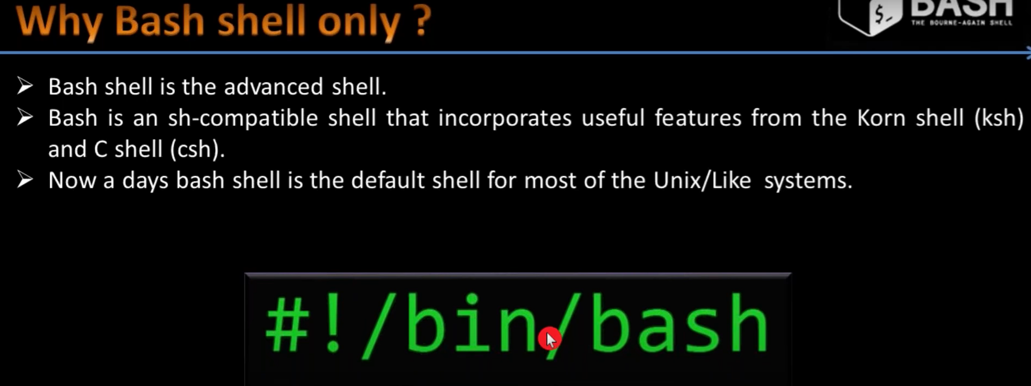

This line “#!/bin/bash” -> this line is knows as sheband line and A script may specify #!/bin/bash on the first line, meaning that the script should always be run with bash,

Script is not all about to just put command , script should be robust , fault solving and should check permission as well like
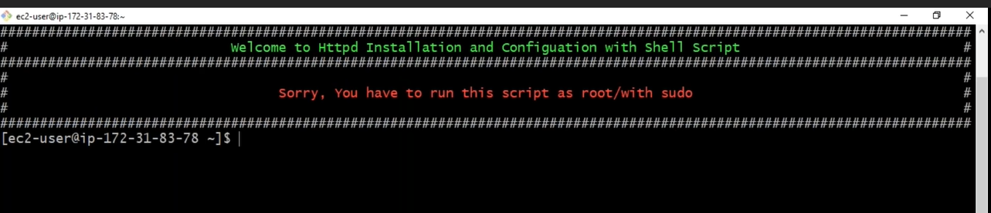

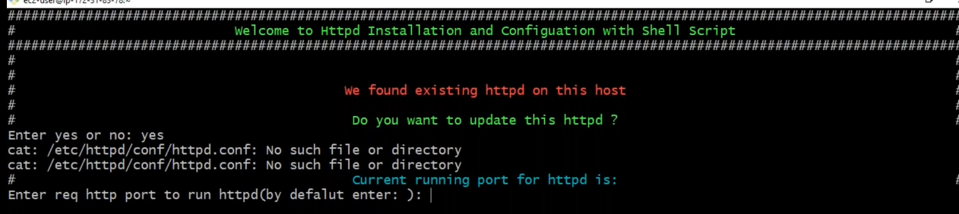

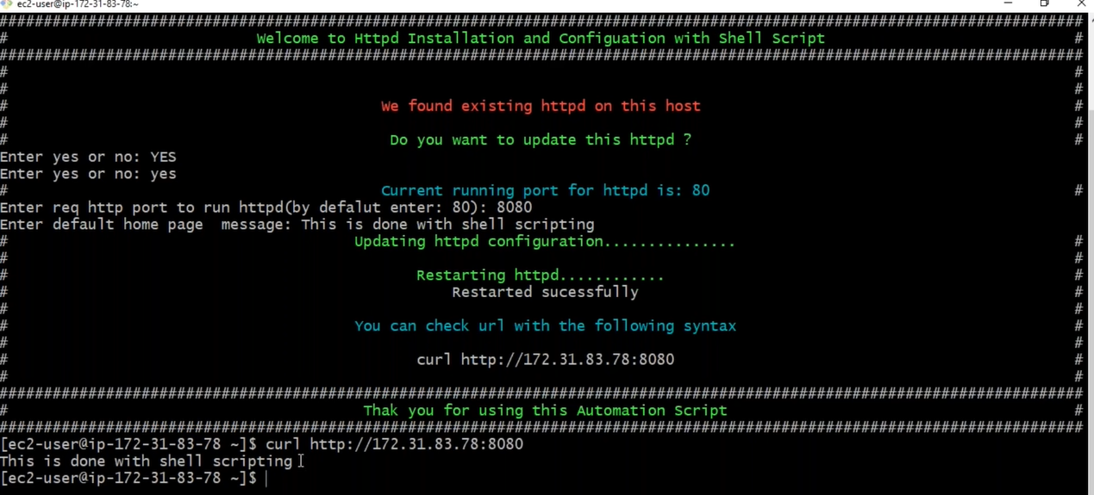

By this we achieve some Automation in Task

